“Sheer Verve”: The Women’s International Art Club (1898-1978)
Ben Uri Gallery, London NW8 ORH, 13 September – 15 December 2023

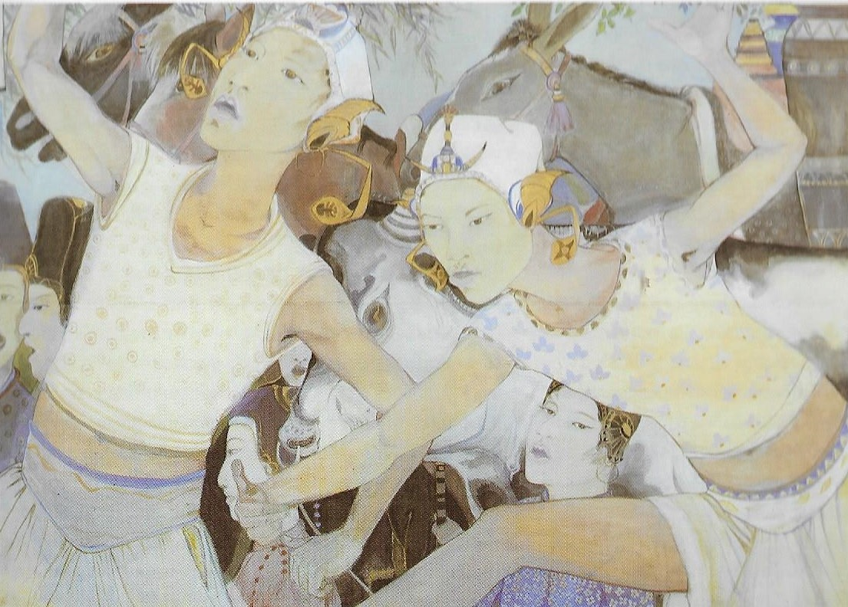
Orovida Pissarro, Ceremonial Dance, 1927, Egg tempera on silk, Private Collection, London © The Artist’s Estate

The Women’s International Art Club (WIAC) was founded in Paris in 1898 as an exhibition platform and networking forum for women artists at a time of restricted opportunities in a male-dominated art establishment. The inaugural exhibition at London’s Grafton Galleries in 1900 went on to become a feted annual event until the club was dissolved in 1978.

Ben Uri has a proud record of collecting, exhibiting and promoting women artists, who currently form 29% of our collection, compared to national average of 3%. Our exhibitions programme has consistently highlighted women artists including Else Meidner (2002), Dora Gordine (2006), Clare Winsten (2008), Judy Chicago (2012), Dodo (2012), and Joan Eardley, Sheila Fell and Eva Frankfurther (2014).
Celebrating the 125th anniversary of the WIAC’s inception, Ben Uri showcases the club’s “sheer verve” (Bettina Wadia, Arts Review, 26 January 1963), juxtaposing work by 20 collection artists from a Jewish and/or immigrant background, among them, Sonia Delaunay, Dora Gordine, Clara Klinghoffer, and Orovida (née Pissarro), with loans from public and private collections by well-known WIAC members Ithell Colquhoun and Laura Knight, alongside celebrated exhibitors, such as Gillian Ayres, Wilhelmina Barns-Graham, Vanessa Bell, Helen Frankenthaler, Elisabeth Frink, Barbara Hepworth, Gwen John, Marlow Moss and Paula Rego, and neglected figures who deserve to be much better-known, among them, Stella Steyn and Ethel Sands.

The WIAC not only survived but often thrived against the backdrop of hard fought-for freedoms within women’s rights, particularly women’s suffrage, two world wars, the rise of feminism and increasing artistic, political and educational freedom. Encompassing paintings, drawings, sculpture and lithographs depicting portraiture, self-portraiture, the nude, landscapes, interiors, still life, and abstracts reflecting this wider history, the exhibition presents an exhilarating snapshot of the club’s correspondingly radical artistic output over seven decades.

A fully illustrated online publication will accompany the exhibition with contributions by leading art historians in the field, together with a related series of events including lectures and podcasts by women artists, art historians, conservators, curators and gallerists, offering a variety of contemporary perspectives.

Notes for Editors

External artists: Eileen Agar (1899–1991), Gillian Ayres (1930–2018), Wilhelmina Barns-Graham (1912–2004), Vanessa Bell (1879–1961), Prunella Clough (1919–1999), Ithell Colquhoun (1906–1988), Helen Frankenthaler (1928–2011), Elisabeth Frink (1930–1993), Barbara Hepworth (1903–1975), Gwen John (1876–1939), Marlow Moss (1889–1958), Winifred Nicholson (1893–1981), Paula Rego (1935–2022), Anne Estelle Rice (1877–1959), Ethel Sands (1873–1962) and Stella Steyn (1907–1987).

Ben Uri artists: Janina Baranowska (1925–2021), Sandra Blow (1925–2006), Ruth Collet (1909–2001), Sonia Delaunay (1885–1979), Amy Drucker (1873–1951), Zena Flax (b. 1930), Lily Delissa Joseph (1863–1940), Elsa Fraenkel ((1892–1975), Dora Gordine (1895–1991), Clara Klinghoffer (1900–1970), Laura Knight (1877–1970), Halina Korn (1902–1978), Margaret Marks (1899–1990), Anna Mayerson (1906–1984), Else Meidner (1901–1987), Erna Nonnenmacher (1889–1980), Lena Pillico (1884–1947), Orovida (née Pissarro, 1893–1968), Adèle Reifenberg (1893–1986), Lotti Reizenstein (1904–1982), Ottilie Tolansky (1912–1977) and Katerina Wilczynski (1894–1978).

The Ben Uri Collection was formed in 1915 in London’s East End by Russian-Jewish decorative artist and craftsman Lazar Berson to support Jewish artists working outside the cultural mainstream. In 2002 the remit widened to include all first- and second-generation immigrant artists, irrespective of national, ethnic, and religious/ non-religious origins, who have helped to enrich Britain’s visual culture. The Collection, begun in 1919, now principally reflects three waves of migration to the UK: first- and second-generation Eastern-European Jewish migration prior to the First World War; the so-called ‘Hitler émigrés’ both Jewish and non-Jewish (1933–45), and wider multicultural immigration after the Second World War. Ben Uri’s collection and exhibiting history often reflect WIAC membership with women from both Jewish and immigrant backgrounds regularly exhibiting at both venues. Lena Pillico was the first female artist to exhibit under Ben Uri’s auspices in 1927, Clara Klinghoffer’s work was the first to enter the permanent collection in 1935, and Lily Delissa Joseph successfully negotiated her artistic, religious, familial, and political identities, while maintaining an international exhibiting profile. Orovida Pissarro, a key and high-profile WIAC member, served on the selection, hanging, and executive committees almost continuously from 1928–1950.

For further information contact: Sarah MacDougall Sarahm@benuri.org
For opening times: see https://benuri.org/

ENDS

